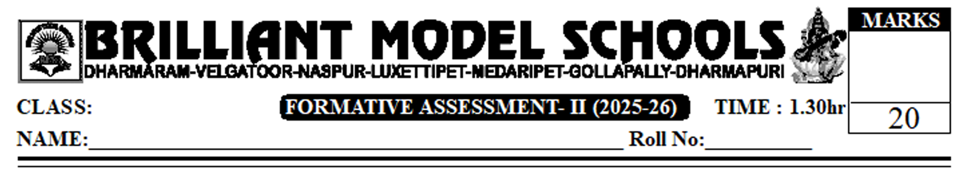

IX Social

I. Answer the following questions. 2x2=4
1. Differentiate between weather and climate?
2. What is industrial revolution? who coined this name?
II. Answer any two of the following questions. 2x3=6
3. A) How do Climatic Changes influence human life? (or)
B) Explain the composition of the atmosphere.
4. A) What were the difficulties faced by women and children during Industrial Revolution? (or)
B) Write a paragraph differentiating the idea of capitalism and socialism..
III. Answer any one of the following question. 1x4=4
5. Read the following para and write your opinion.
The atmosphere of the Earth consisted of different kinds of gases including Water Vapour. Most of these gases were such that life as we know it today could not have survived on it. It didn't have oxygen which is necessary for us. It took a long time for the air we breath to develop.
Or
Describe women social protest movement.
IV. Locate the following places in India Map. 4x1/2=2
- Assom b) Agra c) Jaipur d) Haryana.
Or
Locate the following places in World Map.
- London b) Norway c) Balfic Sea d) China

PART - B.
V. Choose the correct answer. 8x1/2 = 4
- Which gas dominates in atmosphere by volume? ( )
A) Oxygen B) Carbon dioxide C) Nitrogen D) Argon
- ____ Layer is free from clouds? ( )
A) Stratosphere B) Mesosphere C) Stratosphere D) Ionosphere
- The Greek 'oros' means: ( )
A) Rainfall B) mountain C) Humidity D) Wind
- 'Soho Foundry' was in. ( )
A) Birmingham B) London C) Manchester D) Newcastle
- Which Country is called workshop of the world? ( )
A) France B) England C) Sri America D) Russia.
- Steam engine was invented by ( )
A) James Watt B) Edward C) Eli whitney D) Cartil
- Liberty, equality and fraternity were slogans of _____ revolution. ( )
A) English revolution B) American revolution C) French revolution D) Russian revolution
- __________ is not a Socialist. ( )
A) Thomas Moore B) Saint Simon C) Karlmarx D) Charles X

